Induction Pack
NHS [Insert Board Name]
Non-Executive Board Members

[NHS Board to insert appropriate address here
Eg. that of Board Secretary and Tel No:]
Contents | Page No
1. Introduction to NHS Scotland
2. Introduction to NHS [insert board name]
3. Health and Social Care Integration
4. Introductory Meetings for new Non-Executive Board Members
5. Self-Reflection Tool
6. Board Membership and Biographies
7. Governance and Organisational Structure
8. Governance Committees - Terms of Reference
9. Standing Orders
10. Code of Conduct for Non-Executive Board Members
11. Learning Resources for Board Members
12. Glossary of NHS Terms and Abbreviations
ANNEX A - Induction Process Timeline

1. NHS in Scotland

National induction and orientation to the legislation, policies and oversight arrangements between Scottish Government and Health Boards complements the local Induction. The new National Induction approach involves completing a digital training programme which has four components:

- Context - how NHS fits together and arrangements that enable the integration of health and social care.
- Blueprint for Good Governance - how the “Enablers” help Board Members take up their leadership role and fulfils the “Functions” of good governance.
- Creating conditions - for health system quality governance for healthy organisational culture.
- Reflexivity - an approach to capture understanding and learning about the Scottish Health and Social Care system (National and Local) during your six months induction period. This will enable the newly appointed Non-Executive Board Members to appreciate and demonstrate their capabilities in corporate governance at the six month performance review with their Board Chair.

The new National Induction package is under construction and can be accessed on Turas Learn.

This package will include learning modules on the following topics:

- Brief History of the NHS
- Structure of NHS in Scotland
- NHS Scotland and the Scottish Government
- National Strategies
- NHS Values
- Performance Initiatives
- Integration of health and social care
- The 6 Leadership Capabilities for Health and Social Care

2. Introduction to NHS [insert Board]

Welcome to NHS [insert Board] as a new Non-Executive Board Member. I hope you find this pack helpful as you begin your role.

[Insert here background information relating to the respect NHS Board eg residents, number of employees etc. Who you work in partnership etc with eg local population, our patients, our staff, the Health & Social Care Partnership, our colleagues in the Council and the third sector. For a number of specialist services we rely on regional arrangements with neighbouring Health Boards. We have strong links with local educational providers such as the [insert relevant organisations].]

Demographic and Social Profile of NHS [insert Board]

[insert relevant demographic and social information relating to the NHS area here.]

NHS [insert Board]

[insert here fuller details about what your NHS Board provides eg healthcare to over numbers of residents of locality. Also providing information on rural and geographical areas/challenges.]

[insert information on the NHS Board hospitals here and information on community hospitals etc.

NHS [insert Board] Clinical Strategy

[insert here information relating to your NHS Board Clinical Strategy.]

Annual Review

[insert here information relating to the last Annual Review meeting of your Board; eg date, where, by whom and the different meetings etc.]

3. Health and Social Care Integration

The aim of this reform is to meet the challenges of Scotland’s ageing population by shifting resources to community-based and preventative care at home, or in a homely setting.

To achieve this, the Public Bodies (Joint Working) (Scotland) Act 2014 requires councils and NHS Boards to work together to form new partnerships, known as integration authorities (IAs). The aim is to ensure services are well integrated and that people receive the care they need at the right time, and in the right place.

IAs across Scotland are very different in terms of their size, resources and local context. But all IAs are responsible for the governance, planning and resourcing of social care, primary and community healthcare and unscheduled hospital care for adults. Some areas have also integrated additional services including children’s services, social work, criminal justice services and all acute hospital services. Integration authorities manage the budget for providing all integrated services.

Audit Scotland published a helpful guide ‘What is Integration? A short guide to the integration of health and social care services in Scotland’ in April 2018. This guide summarises some key information on the background of health and social care integration in Scotland, and outlines how IAs are structured and function.

Copies can be downloaded from https://www.audit-scotland.gov.uk/uploads/docs/report/2018/briefing_180412_integration.pdf

[insert here local information relating to your NHS Board in relation to integrated services including the number of IJBs and the Non-Executive Board Member role.]

4. Introductory Meetings for New Non-Executive Board Members

It is important for new Non-Executive Board Members to understand the particulars of their Board. Introductory meetings are a key way to get to understand how your role interacts with those within your Board.

The following introductory meetings should be used to enhance your understanding of how the organisation directs and manages services for quality health care through its’ operational structures. By the end of each meeting you should have an understanding of:

- who they are, their role and how that role relates to the Board and Scottish Government;

- strategic actions, policies and initiatives relating to that specific area and how these connect through the assurance routes for corporate governance; and

- the issues affecting that specific area and the implications of these issues when considered together with the issues gathered from each and all the specific areas you have met with. This will enable you to appreciate the challenges and opportunities across the whole governance system and the consequences of the decisions made at Board to drive quality and improvements across the Board.

Meetings to be arranged and topics to be covered therein:

Welcome Letter | Completed
Board Secretary writes to the new Non-Executive Board Member welcoming them to the Board inviting them to get in touch and arrange an initial introductory meeting with the Chairperson and Board Secretary.
Introductory Meeting | Completed
Chairperson and Board Secretary
Overview of the Board’s role in strategy, finance, quality of care and public health; roles and responsibilities of Board Members, including Executive and Stakeholder; appraisal processes and Board evaluation.
A copy of the Induction Pack should be given to the new Non-Executive Board Member at this meeting.

Induction Pack | Completed
Board Secretary
The Board Secretary will prepare the Induction Pack and tailor this following discussion at the Introductory meeting and get this to the Non-Executive Board Member within one week of the meeting.

Introductory Meetings with Board Members |  |  | Completed
As part of the Induction Pack finalisation the Board Secretary will arrange introductory meetings with the following people.
Chief Executive | Date of Meeting:
The Executive Team structure and priorities; the roles of Executives on the Board and its committees; the national and local position on health care delivery and integration.
Chief Operating Officer | Date of Meeting:
Priorities in the Acute service; performance; transformation programmes.
Head of Corporate Governance & Board Secretary |  | Date of Meeting:
The governance structure of NHS [insert board]; arrangements and schedules for Board meetings; Code of Corporate Governance, Members’ Conduct and Register of Interests; IT set-up; expenses; ongoing training and development.
Medical Director |  | Date of Meeting:
Patient safety and quality of care reporting; clinical governance; medical education and training; research and development; quality improvement assurance mechanisms and public/population health.
Director of Workforce |  | Date of Meeting:
Workforce strategy; iMatter/employee engagement; staff governance and partnership working.

Employee Director | Date of Meeting:
The staff governance standard (what the five strands mean for staff); the internal partnership structure and how it works; values and behaviours; the role of the Employee Director.
Director of Finance | Date of Meeting:
Financial governance and stewardship principles; the financial and reporting framework; endowment and charity trustee guidance.
Director of Nursing | Date of Meeting:
Risk management and board assurance framework; community / patient participation and engagement; child and adult protection
Director of Public Health | Date of Meeting:
The population of [insert demographic area] and its health needs; Health Inequalities and work with Partnership Board; the domains of public health and the work of the department.
Head of Communications | Date of Meeting:
Internal communications and external engagement strategies; social media training; organisational structure.

Other | Date of Meeting:
[Insert any other people that new Non-Executives should meet accordingly e.g Chair of the Area Clinical Forum etc]

Chair / Chief Officer of the Integration Joint Boards | Date of Meeting:
[Insert any other people that new Non-Executives should meet accordingly eg Chair of the Area Clinical Forum etc.]

[DN: The following fields are generic as each Board have different ways, they describe their Committees. Please update accordingly. Delete/add as required depending on Boards Committee Structure, all Non-Executives should meet the Chair of Standing Committees as they have accountability across all even those they are not directly involved in.]

Board Committee Chairs | Date of Meeting:
Committee roles, remits and workplans; reporting mechanisms in the governance structure; links to H&SC Partnerships etc.
Board Committee Chairs | Date of Meeting:
Committee roles, remits and workplans; reporting mechanisms in the governance structure; links to H&SC Partnerships etc.
Board Committee Chairs | Date of Meeting:
Committee roles, remits and workplans; reporting mechanisms in the governance structure; links to H&SC Partnerships etc.

Non-Executive Board Member Mandatory Training | Completed
Fire safety awareness
IT security
Display screen equipment
Safe information handling
Equality and diversity

[DN: delete/add as required depending on local NHS Board practices]

Non-Executive Board Member e-Learning | Completed

[DN: delete/add as required depending on local NHS Board practices]
Documents and links provided:
NHS Board Code of Corporate Governance
NHS Board Annual Operating Plan
NHS Board Clinical Strategy and Health & Social Care Strategic Plan
www.nhs.scot
Turas Learn (https://learn.nes.nhs.scot/)
On Board: Scottish Government Guide for Members of Statutory Bodies (https://www.gov.scot/publications/board-guide-members-statutory-boards/)
CIPFA: Good Governance Standard for Public Services (https://www.cipfa.org/policy-and-guidance/reports/good-governance-standard-for-public-services)
Governance for Quality Healthcare in Scotland – an Agreement (https://www2.gov.scot/Resource/0042/00427583.pdf)
Audit Scotland – Reports related to Health (https://www.audit-scotland.gov.uk/report/search?search=&council=All&region=All&sector%5B%5D=health&author=All)
Other activities:
Site visits: acute facility and community-based facility

[DN: delete/add as required depending on local NHS Board practices]

5. Self-Reflection Tool

An important part of the learning process is having the chance to reflect. This space will have a reflective questionnaire/tool for new Non-Executive Board Members to capture their thoughts and reactions throughout the induction process (eg key messages they took away from the introductory meetings; insights gained from the Welcome On Board workshop, and their perspective on the absorption of National policy into local practical action). This tool will be helpful during the six-month initial appraisal conversations to confirm capability and how to best take up your role to strengthen leadership and governance of the Board.

Blank versions of the reflective questionnaire are available from your Board Secretary or to download from TURAS Learn.

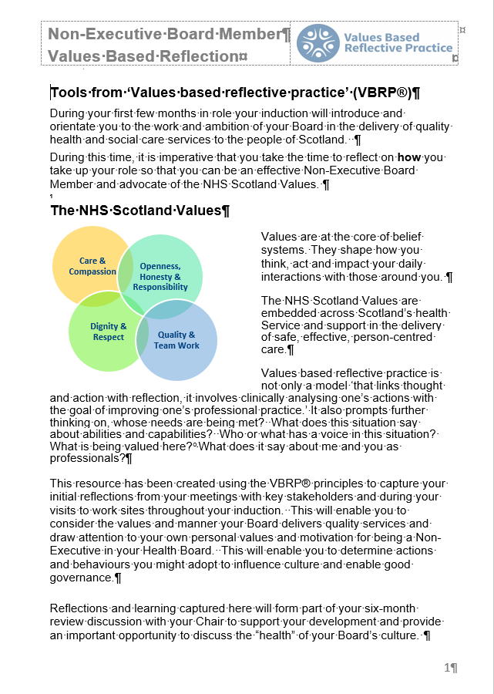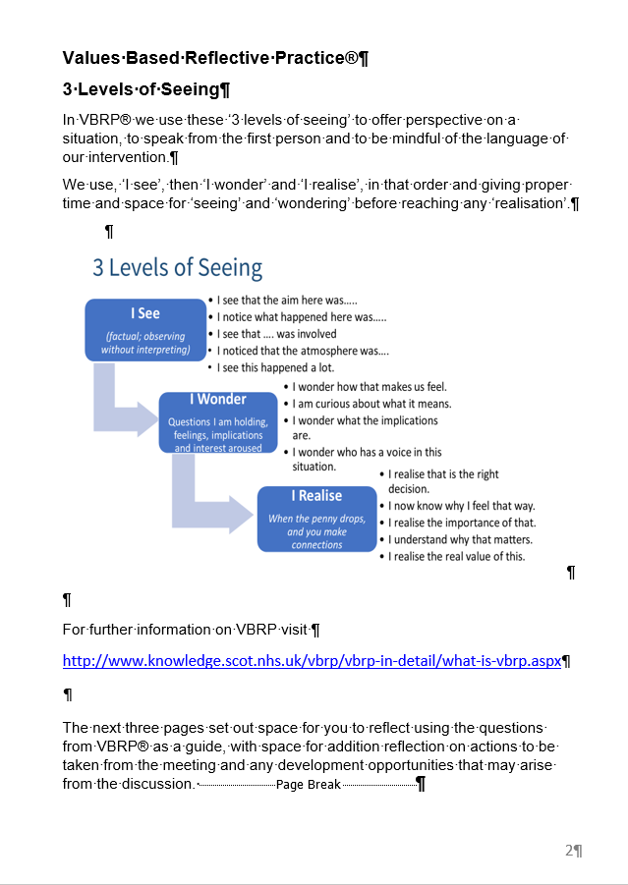

6. Board Membership and Biographies

The Role and Remit of NHS [insert Board]

[Insert information here specific to the health board, specific roles and functions it has.]

Members of NHS [insert Board]

The Board comprises of [insert number] members, as follows (examples below):

- a Chairperson (appointed by the Cabinet Secretary for Health & Sport);
  - [XX] Non-Executive Board Members (appointed by the Cabinet Secretary for Health & Sport);
- [XX] Stakeholder members (eg Staff co-chairperson of the Area Partnership Forum and chairperson of the Area Clinical Forum);
- A member of [Name] Council (nominated by [Name] Council and appointed by Scottish Ministers);
- the Chief Executive of NHS [Board];
- [XX] Executive Directors (Director of Finance, Medical Director, Director of Nursing and Director of Public Health).

NHS [insert Board] Members

Role | Name | Term of Membership
Chair
Chief Executive
Non-Executive Board Members:

Stakeholder Directors:
Employee Director
Chair of Area Clinical Forum
Council Nominee
Executive Directors:
Medical Director
Director of Public Health
Director of Finance
Director of Nursing
Other members of the Executive Directors Group (normally in attendance at Board meetings, examples below add/delete as necessary)
Director of Estates & Facilities
Chief Operating Officer
Director of Pharmacy
Director of Workforce

Board Members Biographies

Each Biography should include the following:

- Education and work/professional career expertise (eg the assets they bring to the Board)
- Areas of responsibility (eg functions, Governance Committees)
- Areas of Special interest/skill (eg digital, stakeholder engagement)

Insert Name and Title eg Chair | [Insert Photo]
Insert Bio information here

Insert Name and Title eg Chief Executive | [Insert Photo]
Insert Bio information here

Insert Name and Title eg Non-Executive Board Member | [Insert Photo]
Insert Bio information here

Insert Name and Title eg Non-Executive Board Member | [Insert Photo]
Insert Bio information here

Insert Name and Title eg Non-Executive Board Member | [Insert Photo]
Insert Bio information here

Insert Name and Title eg Employee Director (Stakeholder Director) | [Insert Photo]
Insert Bio information here

Insert Name and Title eg Medical Director (Executive Director) | [Insert Photo]
Insert Bio information here

7. Governance and Organisational Structure of NHS [insert Board]

[Insert here Board Organisational Chart including how the organisational chart relates to the Assurance route from point of care delivery to Health Board, Executive Directors’ Portfolio information and local information explaining Board’s relationship with IJBs etc.]

8. Governance Committees - Terms of Reference

[Insert here the governance committees that report directly into NHS [insert Board] and their terms of reference as appropriate see examples below, these should reflect the Board Committee list on page 9:

- Audit and Risk Committee (A&R)
- Clinical Governance Committee (CG)
- Finance, Performance and Resources Committee (FP&R)
- Staff Governance Committee (SG)

9. Standing Orders

A copy of the Standing Orders which apply to all Boards is available from the www.nhs.scot website or [insert local NHS Board Website Address].

10. Code of Conduct for Non-Executive Board Members

Context

NHS Board Members all have a legal duty to follow the NHS Board Code of Conduct. The Standards Commission for Scotland promotes and enforces the Codes of Conduct for Members of devolved public bodies (such as NHS Boards and Integration Joint Boards), and publishes guidance to help those appointed as Members of such bodies. The Code of Conduct is based on the National ethical standards and the NHS Values which form part of the National Induction package.

As a NHS [insert Board] Member you are personally responsible for:

- Ensuring that you are familiar with the provisions of the Code; and
- Ensuring that your actions comply with the provisions of the Code.

Some NHS Board Members will also be Councillors and / or members of an Integration Joint Board and will also have to observe the Code of Conduct of those other bodies. As well as observing certain standards of General Conduct under section 3 of the Code and matters relating to Lobbying and Access to Members of Public Bodies under section 6, you also have to take the following actions:

- Maintain your entry on the Register of Interests

The NHS Board itself has to create and publish the register and has appointed the Board Secretary as the ‘Standards Officer’, who advises Members on the Code, and keeps the Register up-to-date on the Board's website.

It is your responsibility to register any interest which the Code requires you to register and keep your entries up-to-date. For example, you have a registerable interest when you own or have any other right or interest in houses, land and buildings, which may be significant to, of relevance to, or bear upon, the work and operation of the NHS Board. The test to be applied when considering appropriateness of registration is to ask whether a member of the public acting reasonably might consider any interests in houses, land and buildings could potentially affect your responsibilities to the NHS Board and to the public, or could influence your actions, speeches or decision making.

You are not required to register the interest of "other persons" who are close to you, however you may be required to declare such interests (see below).

- Declare your interests

Declaration of interests comes under particular public scrutiny and is commonly featured in complaints to the Standards Commissioner. It is important that the public and other stakeholders are confident that decisions are being made in the public interest and not for any other reason.

In addition to any registered interests, you may need to declare an interest at a meeting before a particular item is discussed. At the start of every meeting the chair shall invite members to declare any interests. Any interest you declare may or may not already be on the register of interests. When deciding whether or not to declare an interest, you need to consider the Objective Test:

"Whether an ordinary member of public with knowledge of the relevant facts, would reasonably regards the interest as so significant that it is likely to prejudice your decision making".

You also need to declare any financial or non-financial interests of any people or organisations you are connected with, eg spouse, partner, close relative or friend, employer or business partner.

The Standards Commission has granted a dispensation to NHS Board Members (and a similar one to councillors) who have been appointed as a member of an Integration Joint Board. "This is so members do not have to declare their interests when discussions on general health and social care issues arise and can participate in discussion and voting on these issues".

If you decide you have an interest that requires to be declared, then you must declare it and leave the meeting for the duration of the item under discussion.
You should identify the need to declare such interests as early as possible and notify the chair of the meeting. If you have to leave the room, this may have an impact on whether the meeting will be in quorum when the item is being discussed. If you are the chair of a meeting, you should ensure there are arrangements in place for another member to take on the role of chair while you have left the meeting.

[Insert here NHS Board Code of Conduct or advise Non-Executive Board Member where this can be found on website if appropriate]

12. Learning Resources for Board Members

There are many learning and development resources available that are specifically tailored to the individual needs of NHS Board Members. This section provides some examples of external resources that will be of particular interest to newly-appointed Board Members.

Turas Learn

Turas Learn is NHS Education for Scotland's platform for learning and support resources (https://learn.nes.nhs.scot/). It provides all NHS Scotland health and social care staff access to learning and practice support resources produced by NHS Education for Scotland.

Non-Executive Board Members will have a private learning area dedicated to their induction and ongoing development needs. This space is currently being designed and will host interactive elearning modules, updates on learning and networking events, links and documentation on relevant topics as well as offering access to mentoring and coaching opportunities.

In addition to Turas Learn all NHS Board Members are eligible to register for an account at the NHS Knowledge Network, which holds a wealth of information on topics related to healthcare management, planning, policy and development. There are, for example, specific resources aimed at Board Members and Executive-level management.

National Induction

An overview and orientation for Non-Executive Board Members, giving the national context for Health and Social Care in Scotland is available on Turas Learn.

Workshop for Public Appointees

In addition to national and local induction the Scottish Government has developed a “Welcome On Board” workshop for Board Members appointed through the Public Appointments route. This workshop builds on the induction process Members receive at their respective Boards and highlight Scottish Ministers' expectations of them while encouraging newly appointed board members to network across Scotland.

Each workshop includes the following speakers; a Scottish Minister, a representative from the office of the Commissioner for Ethical Standards in Public Life in Scotland, and a representative from Audit Scotland.

The workshops are run up to three times a year, ensuring that every newly appointed board members has the opportunity to participate within six months of their appointment start date. Further information can be found on Board Members page on Turas learn.

You will also have been given access to the ‘Governance Portal’ which contains an e-learning version of ‘On Board’ and a discussion forum.

New members of public body boards may wish to familiarise themselves with the following documents:

- Audit and Assurance Committee Handbook [no link]
- Audit Scotland Publication: The Role of Boards
- Good Governance in the Scottish Government
- On Board: A Guide for Members of Statutory Boards
- Model Code of Conduct for Members of Devolved Public Bodies
- Non-Executive Board Member toolkit
- Regional Plans [Boards to insert link to regional plans]
- Scottish Public Finance Manual (SPFM)

Scottish Government publications for Non-Executive Members of NHS Boards

The Scottish Government also publishes a series of booklets targeted specifically at Non-Executive Members of NHS Boards, to assist members in developing an improvement-focussed approach across all domains of governance and supporting their contribution to achieving the Scottish Government’s healthcare ambitions. Copies may be found online at the following links:

- Quality Improvement and Measurement
- Quality, Efficiency and Value
- Being Effective
- Safety Checklist
- Person-centred Care
- Improvement Focused Governance

Please note the booklets are currently being updated to reflect the Blueprint for Good Governance.

12. Glossary of NHS Terms and Abbreviations

The NHS frequently uses a large number of acronyms, a selection of which are explained here. Definitions of other commonly used acronyms can be found on the NHS Confederation’s Jargon Buster website.

[insert any additional Abbreviations relevant to your health body]

18 Weeks RTT | 18 weeks Referral to Treatment
A&E | Accident & Emergency
ABI | Alcohol Brief Intervention
ACF | Area Clinical Forum
ADC | Area Distribution Centre
ADP | Alcohol & Drugs Partnership
ADTC | Area Drug & Therapeutics Committee
AfC | Agenda for Change
AHP | Allied Health Professionals
AMAU | Acute Medical Admission Unit
AMC | Area Medical Committee
APF | Area Partnership Forum
Arbuthnott | Formula for allocating revenue on a national basis being replaced by NRAC (see below)
ASAU | Acute Surgical Admissions Unit
BNF | British National Formulary
CAMHS | Child and Adolescent Mental Health Services
CBT | Cognitive Behaviour Therapies
CCU | Coronary Care Unit
CD | Clinical Director
C.Diff | Clostridium Difficile
CEO | Chief Executive Office
CFS | Counter Fraud Services

CHD | Chronic Heart Disease
CHI | Community Health Index
CLO | Central Legal Office
CNA | Could Not Attend
COPD | Chronic Obstructive Pulmonary Disease
COPS | Chief Officers Public Safety Group
CPN | Community Psychiatric Nurse
CPP | Community Planning Partnership
CRES | Cash Releasing Efficiency Savings
CRL | Capital Resource Limit
CT (scanner) | Computerised Tomography (scanner)
DOF | Director of Finance
DNA | Did Not Attend
DPA | Data Protection Act 1998
DVT | Deep Vein Thrombosis
EDG | Executive Directors Group
EDISON | An NHS system used to manage delayed discharges
ENT | Ear, Nose & Throat
EQIA | Equality Impact Assessment
EWTD or EWTR | European Working Time Directive or Regulations
FOI | Freedom of Information
FOISA | Freedom of Information (Scotland) Act 2002
FY1/FY2 | Foundation Year 1/2 (Medical Trainee)
GIRFEC | Getting It Right For Every Child
GJNH | Golden Jubilee National Hospital
GMS | General Medical Services
GPwSI | GP with Special Interest

GUM | Genito-Urinary Medicine
H&SCP | Health and Social Care Partnership
HEAT Targets | Health Improvement  Efficiency and Governance  Access to Services  Treatment Appropriate to Individuals
HAI | Healthcare Associated Infection
HDU | High Dependency Unit
HEI | Healthcare Environment Inspectorate
HIS | Healthcare Improvement Scotland
HR | Human Resources
ICASS | Integrated Community Assessment and Support Service
IJB | Integration Joint Board
IMPACT | Improvement, Planning and Change Team
IP | In-Patient
IPR | Integrated Performance Report
IS | Information Services
ISD | Information Services Division
IT | Information Technology
ITU | Intensive Therapy Unit
JHIP | Joint Health Improvement Plan
JIT | Joint Improvement Team
KCND | Keep Childbirth Natural and Dynamic
KSF | Knowledge and Skills Framework
LDP | Local Delivery Plan
LMU | Local Management Unit
LoS | Length of Stay
LPF | Local Partnership Forum
LTC | Long Term Conditions

MaxFax | Oral and Maxillofacial Surgery
MCC | Modernising Clinical Careers
MCaN | Managed Care Network
MCN | Managed Clinical Network
MMC | Modernising Medical Careers
MOU | Memorandum of Understanding
MRI | Magnetic Resonance Imaging
MRSA | Methicillin-resistent Staphylococcus aureus
MSN | Managed Service Network
NES | NHS Education Scotland (a Special Health Board)
NRAC | National Revenue Allocation Committee
Obs & Gyn | Obstetrics and Gynaecology
OPD | Out-Patients Department
Paeds | Paediatrics
PCES | Primary Care Emergency Service
PDP | Personal Development Plan
PEN | Public Engagement Network
PFB | Patient Focussed Booking
PFPI | Patient Focus and Public Involvement
PIN | Partnership Information Network
PTS | Passenger Transport Service (managed by the Scottish Ambulance Service)
RHSC | Royal Hospital for Sick Children (Edinburgh or Glasgow)
RRL | Revenue Resource Limit
SAB | Staphylococcus Aureus Bacteraemia
SAS | Scottish Ambulance Service
SCN | Senior Charge Nurse
SEAT | South East and Tayside Regional Planning Group

SGHSCD | Scottish Government Health and Social Care Directorates
SIG | Strategy Implementation Group
SIGN | Scottish Intercollegiate Guidelines Network
SOA | Single Outcome Agreement
SPF | Scottish Partnership Forum
SPSP | Scottish Patient Safety Programme
SWAG | Scottish Workforce and Staff Governance
TTG | Treatment Time Guarantee
VHK | Victoria Hospital
WLI | Waiting List Initiative

