Performance Appraisal and Development

NHS Board Chairs

Reviewing my behaviour

Guide to setup multi rater feedback

This guide is designed to help you set up the multi rater feedback. Multi rater feedback is a compulsory element of the NHS Board Chair performance appraisal and development process.
Multi rater feedback provides the opportunity for you to gain a snapshot of how your leadership style, approach and behaviour is experienced by your reviewer and others you interact with. The multi rater component gives a more rounded perspective on how you have led the Board in delivering quality care to the people of Scotland.
The multi rater component provides insight on your strengths and development goals. It complements your appraisal of overall performance which is determined through the completion of all five sections of the performance appraisal and development documentation.
Introduction
The NHS Board Chairs multi rater feedback is an automated multi rater tool which has standard steps and roles. The Corporate Business Management Team provides the Administrator function for the NHS Board Chair multi rater feedback.
The multi rater feedback involves four steps:
- Self-assessment - rate yourself against 25 behavioural statements which are based on the NHS values and the five governance functions set out in the Blueprint for Good Governance.
- Invite feedback from others - inviting feedback from people who have personal experience of your leadership of the NHS Board within the last 12 months.
- Generating your report - brings together the results of your self-assessment and the feedback you have invited from others.
- Capturing learning from reviewing your report - incorporate the insights from the report into p6 of your appraisal documentation. This will prepare you for your performance and development review with your reviewer. It will give you insight to sustain and improve your impact and effectiveness as a leader.

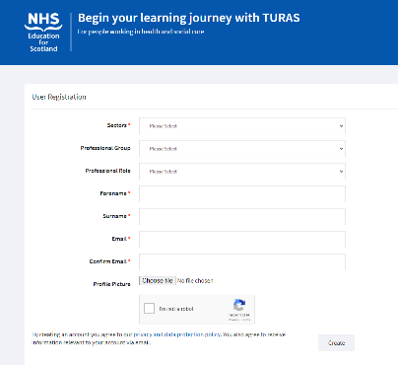
- Self-Assessment
Once the Administrator has set
up your feedback questionnaire,
a link will be sent to you on email. It is important that you use the link to access the Feedback survey on Turas.
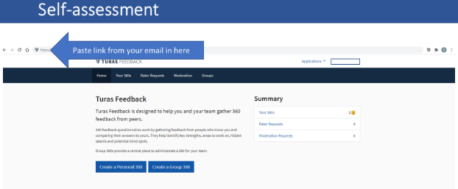
If you do not have a Turas account, type “Register for Turas” into any search engine and complete the registration form.
Once signed into Turas, click on the “Feedback” tile on the dashboard and copy the link from the email sent to you by Scottish Government and paste it into the browser.
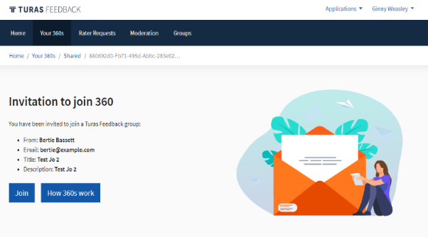
Then click “Join”.

You will then be directed to complete a self-assessment against 25 statements relating to the five functions of good governance.
The 25 statements are included as an Appendix for your information.
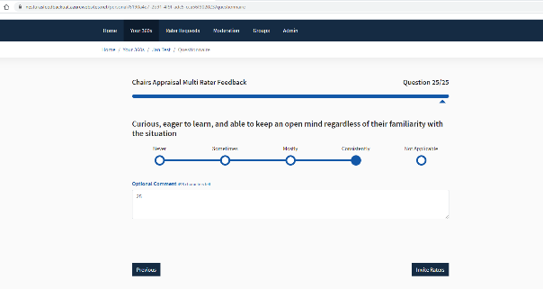
You can add comments to each statement however this is not mandatory. At the end of the 25 statements you will be invited to “Add raters”.

If you want to review or amend your self-rating answers you can do this either by clicking “Previous” before you add your raters, or you can go back and review or amend your self-rating at any time until you generate your report. To check and amend your self-assessment this way just log into Turas Feedback, select “My 360”, find your assessment in the “Details” and click “Review Answers”.
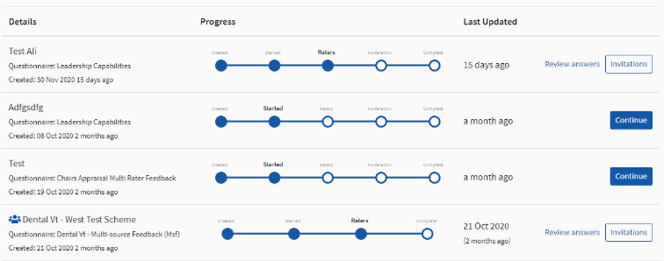
By completing this self-assessment, it will give you a sense of how you see your strengths and where best to focus your energy to increase your impact or effectiveness.

Once you have completed your personal assessment you can invite your Raters.

- Invite feedback from others
The following explains how to add your raters onto the system. As the NHS Board Chair, it is your role as Instigator to invite raters to give feedback. There are three rater categories: Executive Team, Non-executive Team and Strategic Stakeholders.
Identifying the most appropriate people to rate your performance is a key part of the process and you are in the strongest position to identify who is best to provide reliable ratings and meaningful feedback.
You must invite and have assessments completed by those shown below. Anonymity is a key consideration and you should ensure you have enough people in each of the three rater categories.

Rater categories for NHS Board Chair multi rater feedback:

Mandatory Stakeholders | Suggested Stakeholders
Executive Board Members (All) | Board Secretary
Non-Executive Board Members (All) | Patient Bodies
NHS Chairs – minimum ask 3 | Staff Side Representatives
Council Leaders (for Territorial Boards) | Other National Groups
 | Chief Officers of IJBs
Important: You will need the name and email address of everyone you would like to invite to give feedback in each of the rater categories and decide which rater category you have allocated them and let them know to pick this.
Tips:
- Choose people who have had the opportunity to observe you sufficiently to have a realistic idea of how you typically behave.
- Choose people you trust to give honest feedback.
- You will get a more rounded and complete view if you ask people to provide feedback from those who see you in several different contexts.
- Send your raters an email to alert them you are seeking their feedback as part of your appraisal and to expect and respond quickly to the invitation automatically sent to them by Turas 360. Here is an example email.

Here is an example email to send to your raters inviting them to participate.

Sample email to send to raters for giving feedback.
Dear Colleague,
I am reflecting on my performance and the style, approach and behaviour I adopt when leading the Board. I would appreciate your feedback and have included you as one of my raters for a multi rater feedback report. You can expect to receive an email from Turas 360 inviting you to provide feedback on me against behaviours relating to the Blueprint for Good Governance functions.
I would be most grateful if you could look out for this invitation and respond quickly and fully to it so as not to delay the generation of my report.
Please select the INSERT RATER CATEGORY you have allocated them here
If you do not have a Turas account, please paste this link into your search engine browser and complete the registration form. https://turasdashboard.nes.nhs.scot/User/PersonalDetails/Create?openIdApplicationId=e8c7cbb9-34fd-4c87-8c6c-7232cf6786d7
Thank you in anticipation.
The following screen will pop up when you click “Invite raters”

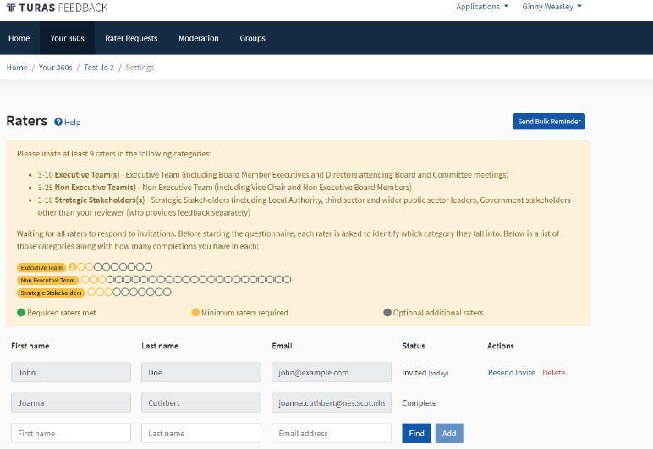
You need to add the names and email addresses onto the Turas 360 system and your raters will automatically be contacted. To do this follow the instructions below:

Review the rater categories and ensure you are inviting at least the minimum for each category (you have to indicated in your invitation email which category you have selected)

Input their email into the correct field. You can do this by either finding them on Turas (click “Find” then press “Add”), or just “Add” them manually.
When you press “Add”, this automatically sends a TURAS 360 email to your rater, inviting them to give feedback.
There are several ways to manage your Raters: -
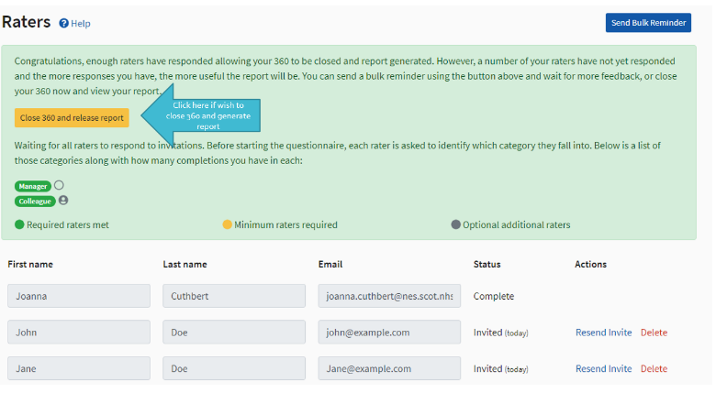
- You can delete raters you have added
- You can resend invitations for maximum feedback
- You can see who has completed
- You can send reminders to raters to prompt raters to complete the questionnaire in a timely fashion (only raters who have still to complete the assessment will be prompted).
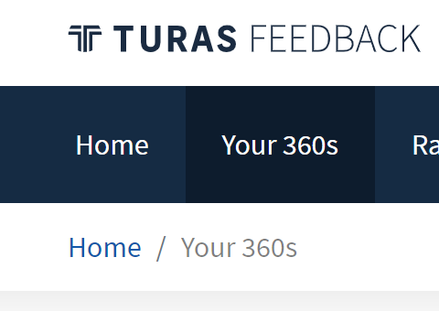
You can check progress with your multi rater assessment at any time by logging into Turas and clicking “Your 360s”

- Generating your report
You can close the assessment and generate your Feedback Report anytime after the minimum number in each category has been reached (you might want to keep it open and prompt others to respond to get maximum feedback).
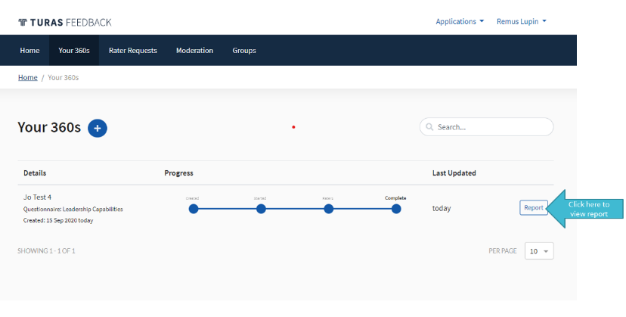
Your feedback report can provide you with the insights required to guide you towards specific development goals to sustain or enhance your impact and effectiveness.

Remember, differences in perception are common and can add to the quality of the conversation with your Reviewer.

- Capturing learning from reviewing your report
Return to your Performance Appraisal and Development documentation and capture the key themes and learning about your behaviour and leadership style from your feedback report. You will find this in Section four – Reviewing my behaviour on page 6.
Share your feedback report along with your “in progress” appraisal documentation with Scottish Government Corporate Business Management Team in advance of your scheduled meeting with your Reviewer.

Appendix 1
Reviewing the Chair’s Behaviour
The behavioural statements that form the multi rater feedback on Turas are shown here for reference by the NHS Board Chair.
The rating scale is: Rarely Sometimes Mostly Consistently
Setting the direction | - Oversees the creation and implementation of an engaging, impactful and achievable strategy
 | - Ensures wide consideration of internal and external factors is given to both the creation and delivery of the strategy
 | - Allows sufficient time for the Board to discuss future as well as current considerations
 | - Ensures the existence of a clear plan for achieving the strategy that is meaningful to staff and the wider population
 | - Has their finger on the pulse locally and nationally, alert to what is happening, ensuring Board members are up to date
Holding to account | - Ensures robust and appropriately strategic levels of oversight and scrutiny are applied to performance & improvement
 | - Ensures the Board has clear and appropriate governance structures and assurance systems to hold people to account
 | - Balances challenge with support, calmly raising concerns and giving people space to develop their own solutions
 | - Ensures compliance in relation to regulatory requirements is maintained and issues are reported / addressed promptly
 | - Allows all voices to be heard and views respected, capitalises on the richness of experience and insight within the Board
Assessing risk | - Ensures Board Members review risk at the appropriate level and wider accountability for risk is taken at all levels
 | - Ensures the right information is available for risks to be understood and that this informs strategic decision making
 | - Creates psychological safety and a willingness to share mistakes through modelling openness, trust and transparency
 | - Ensures the organisations risk appetite is aligned to its strategic ambitions and the future needs of the population
 | - Embodies all aspects of governance and displays a thorough understanding of the regulatory and compliance context
Engaging  Stakeholders | - Ensures the alignment of the strategy between partner organisations and with regional and national priorities
 | - Proactive in developing external relationships and partnerships locally and nationally, embraces an ambassadorial role
 | - Inclusive and involving of the diverse range of people within the system, valuing their ideas and perspectives
 | - Looks beyond traditional organisational boundaries, building consensus for an integrated vision of the future
 | - Resolves disagreements by bringing people together, discussing things openly and finding common ground
Influencing  Culture | - Focusses others on need to foster a culture built upon kindness, empowerment, inclusivity and the NHS Scotland Values
 | - Attracts and retains a diverse, representative and talented Board who share commitment to the strategy and values
 | - Remains calm and centred despite distractions and interruptions, retaining a sense of focus and perspective
 | - Displays insight into how their behaviour, attitude and actions impact others, and adapts their style appropriately
 | - Curious, eager to learn, and able to keep an open mind regardless of their familiarity with the situation

